Personal, Social, Emotional Development  This term the children will be settling in and making new friends. They will be learning all our rules and how to use the provision correctly, as well as tidy it away. They will build on what they know about sharing and taking turns. They will become more confident to select their own resources and to ask for help when they need it. The children will also be learning to identify their feelings and how to respond to feelings of others. | Communication and Language  The children are practising how to sit and concentrate for longer periods of time in their lessons, to listen carefully and to put their hand up to respond. They will also be following more instructions at one time and answering questions in depth about their experiences and books that they have read. They will be encouraged to retell familiar stories in their own language, make up stories in the role-play and small word areas, and speak clearly in front of the class during Show and Tell. | Physical Development  The children will be doing lots of fine motor tasks this term (fiddly little tasks that require dexterity in the fingers) in order to improve their pencil control when it comes to handwriting. They will also begin to learn our cursive handwriting script, using a range of media.  In PE the children will be learning how to navigate around others safely during their Tag Rugby sessions with Mr Dailey and will have time to use large scale equipment such as bikes, crates and planks.
Literacy  The children will be learning the basic phonics sounds and some digraphs such as ch, sh, ng and qu and blending these sounds together to read words. They will be taught to write the sounds they can hear in words and eventually they will begin to hear more of the sounds in each word.  The children will be enjoying a range of texts with repetitive language and the children’s interests will dictate which texts we will be enjoying this year. | Cheselbourne Village School  Curriculum Note for Parents  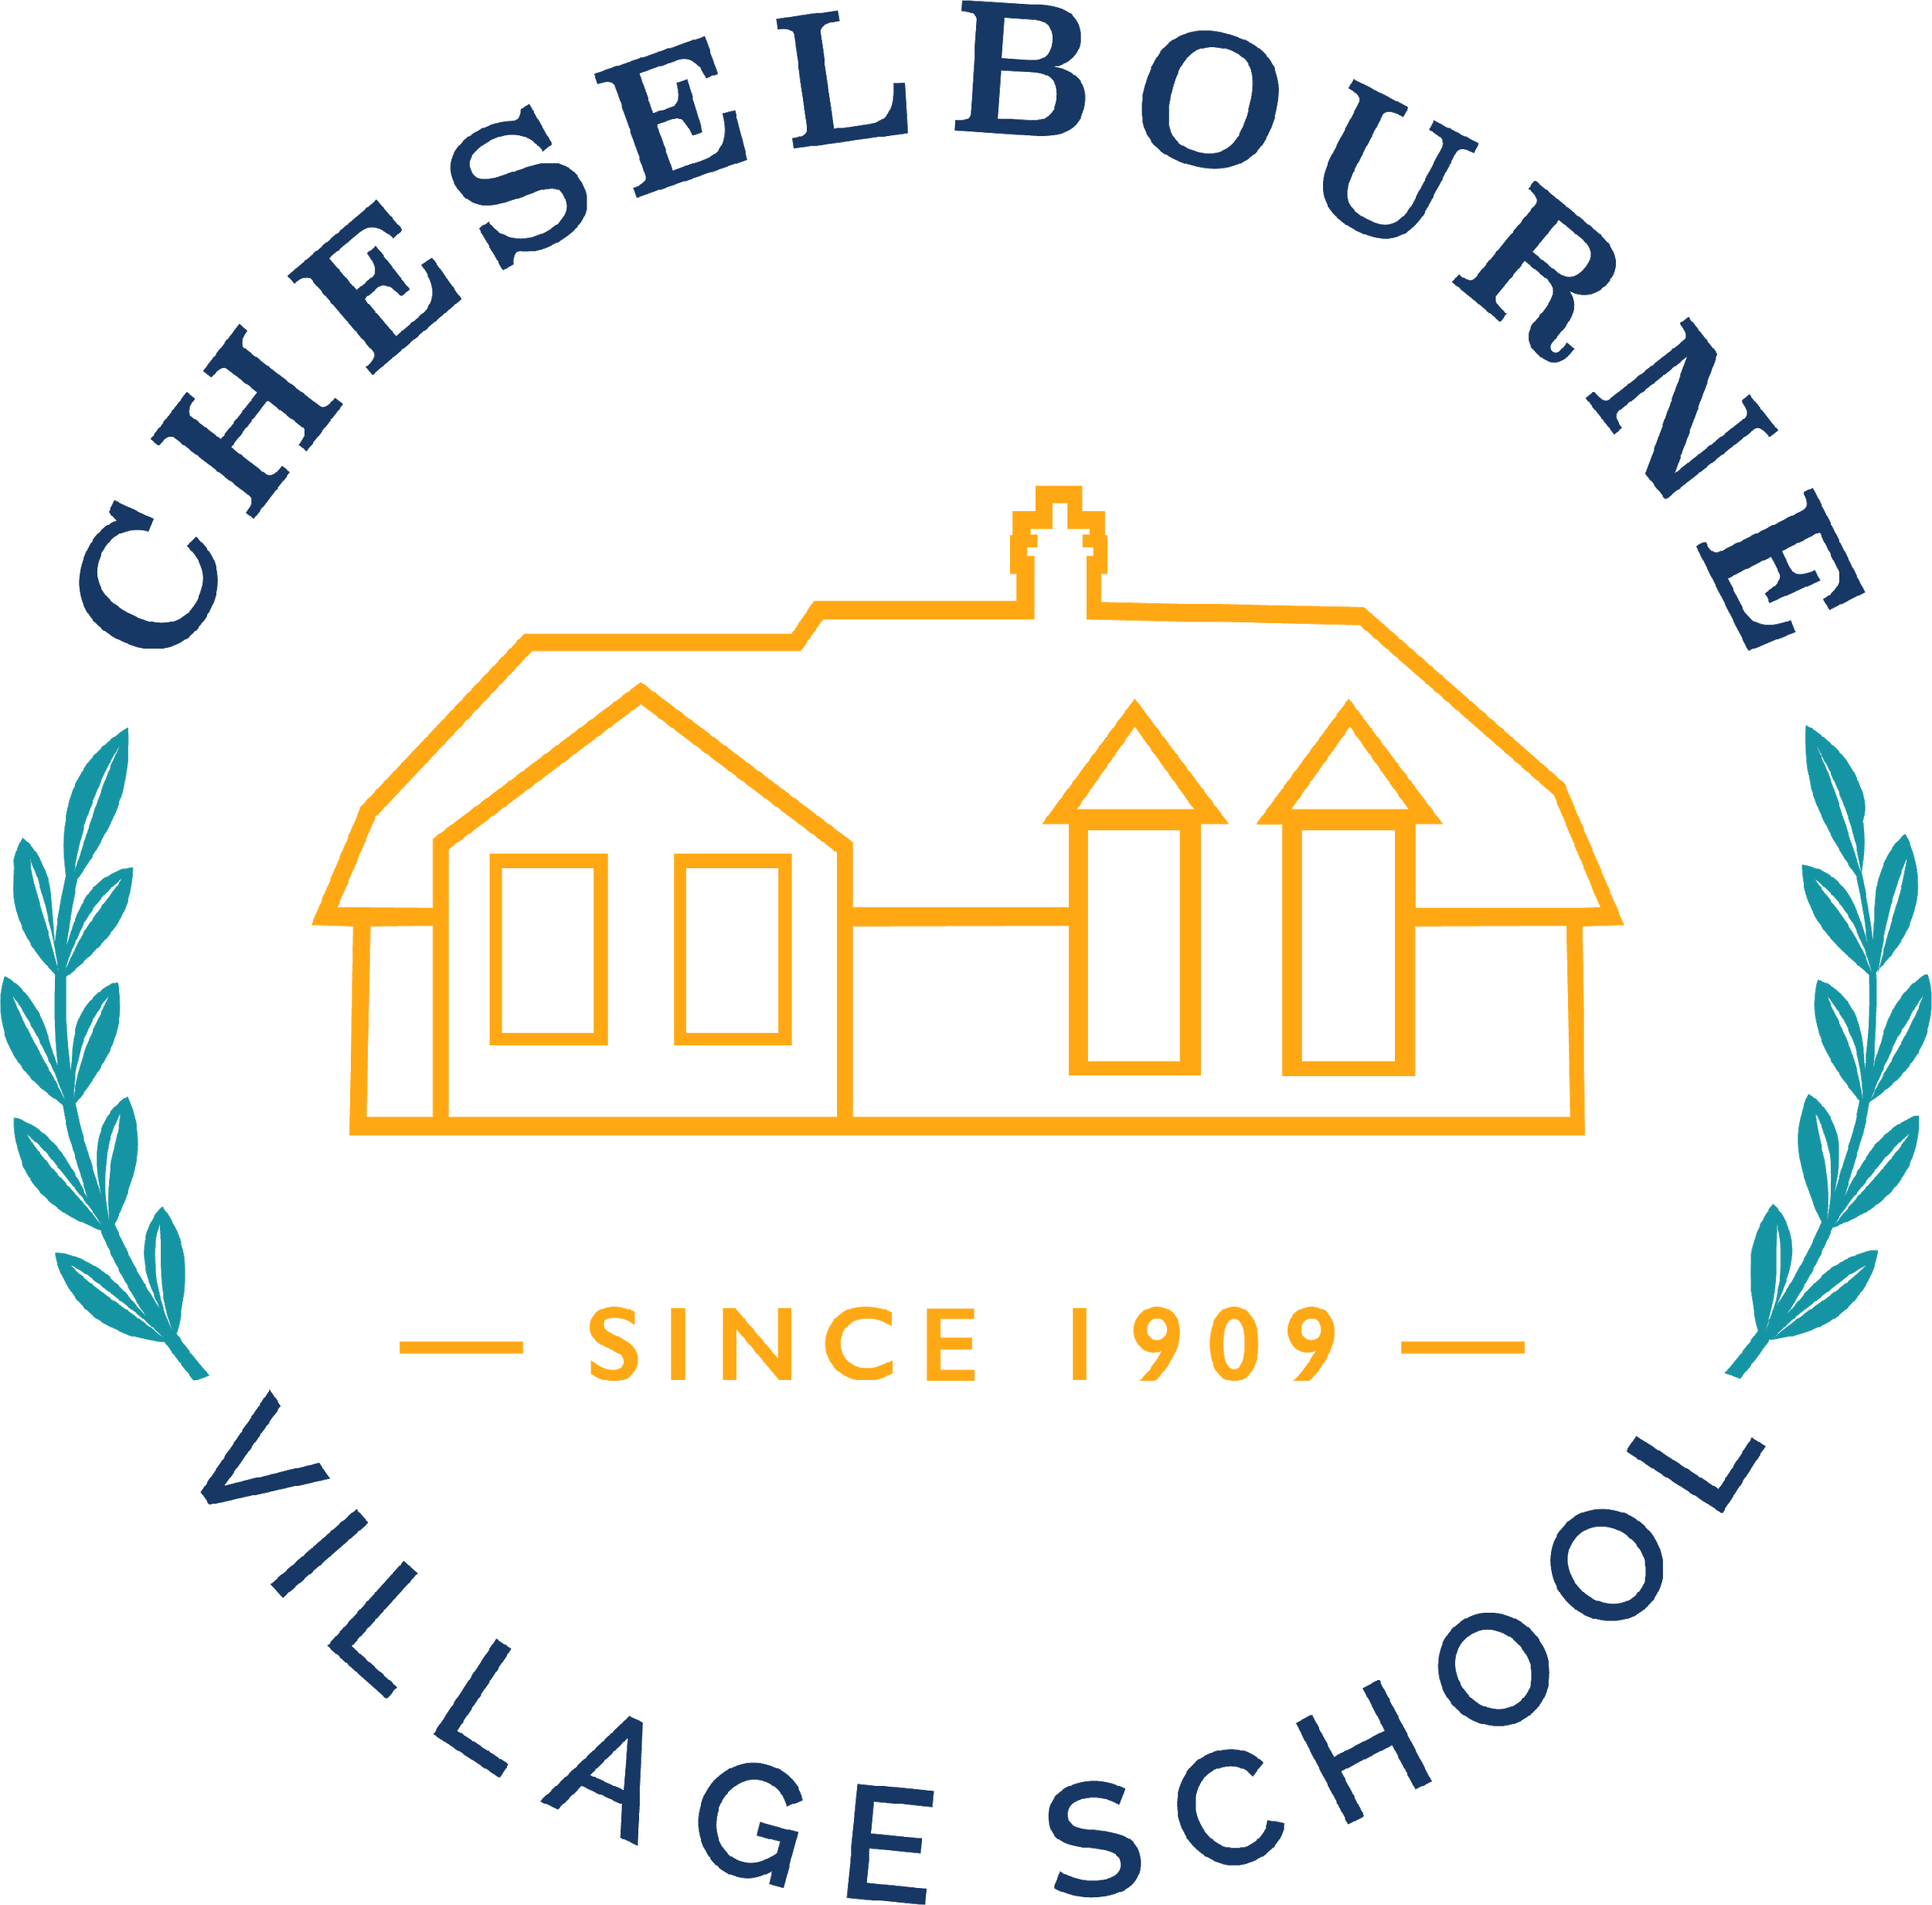  Autumn Term  EYFS Butterflies | Maths  The children are going to be focusing on numbers 1-10 this term. We will be examining each number closely and looking at how each number breaks down. For example: 5 objects can be partitioned as 1 & 4, 2 & 3 or 0 & 5.  The children will also be making repeated patterns, learning about 2D and 3D shapes and practising accurate counting by playing lots of maths and problem games.
Understanding the World  The children will be learning about the immediate environment of the school, its surroundings and talking about their homes. We will be building on what they notice in their environment and extending their knowledge of what interests them.  The children will be learning how to use educational apps using our iPads and some basic computer skills such as using a mouse and how to complete a simple program. They will also be learning how to operate a digital camera. | Characteristics of Effective Learning  This topic is really exciting and encourages the children to develop a broad range of skills.  The children will be challenged to ask high order questions, plan how they want to achieve a goal and then review their work thinking about what went well and what they could do better. This enables them to be independent successful learners supporting them into year 1. We will be looking for children to demonstrate whether they are active learners, enjoy creating and thinking critically or thrive playing and exploring. | Expressive Art and Design  The children will be learning how to use our Make and Do area and our Art area independently. They will have access to a range of art materials and media. They will be taught a range of joining skills so they can create models from recycled materials. They will learn how to use musical instruments safely and how they can be used to make more than one sound. The children will be encouraged to make up their own stories in the role play area with their friends.

